ASIC Implentation for a Full Swing Opamp.
DAU, Gandhinagar, India
Deepak Chidambaran, Rutu Parekh
202411028@daiict.ac.in, rutu_parekh@daiict.ac.

Abstract— The NMOS input pair folded cascode amplifier is a widely used topology in analog circuit design due to its ability to achieve high gain, wide bandwidth, and improved input common-mode range under low-voltage conditions. In this work, a folded cascode operational amplifier employing an NMOS differential input pair is designed and analyzed. The folded structure allows efficient level shifting of signals, enabling better utilization of voltage headroom compared to conventional cascode amplifiers. The proposed design offers high open-loop gain, enhanced slew rate, and improved frequency response, making it suitable for high-speed and precision applications. Key performance parameters such as gain, bandwidth, input common-mode range (ICMR), and output swing are evaluated to validate the effectiveness of the architecture. The amplifier is particularly suitable for applications in data converters, switched-capacitor circuits, and sensor interface systems. Simulation results demonstrate that the design achieves a good trade-off between power consumption, speed, and accuracy, making it a reliable choice for modern analog and mixed-signal integrated circuits.
Keywords— folded cascode, ICMR, power consumption.

Introduction
Operational amplifiers are fundamental building blocks in analog and mixed-signal integrated circuits, widely used in applications such as data converters, filters, and sensor interfaces. With the continuous scaling of technology and the demand for high-speed and low-voltage operation, conventional amplifier topologies often face limitations in terms of gain, bandwidth, and output swing.The folded cascode architecture has emerged as an effective solution to these challenges by providing high gain and wide bandwidth while allowing better utilization of voltage headroom. In particular, the use of an NMOS differential input pair offers advantages such as higher electron mobility, which results in improved transconductance and faster response compared to PMOS-based designs.In this work, an NMOS input pair folded cascode amplifier is designed to achieve a balance between high gain, large bandwidth, and low power consumption. The folded structure enables the input signal to be processed efficiently while maintaining a wide input common-mode range and improved output swing. Key design considerations such as biasing, device sizing, and operating region are carefully addressed to ensure optimal performance. This amplifier topology is well suited for modern analog applications, including high-speed data converters, switched-capacitor circuits, and precision sensor interfaces, where both accuracy and speed are critical requirements.The architecture includes three primary blocks: a sample-and-hold circuit, a comparator array, and a digital encoder.
The designed amplifier operates with a supply voltage of 5 V and ground as the reference (VSS). It achieves a high slew rate of 20 V/µs, enabling fast signal transitions, and incorporates a Miller compensation capacitance of 1 pF to ensure stability. The amplifier provides a gain-bandwidth product of 100 MHz, making it suitable for high-speed applications. The input common-mode range (ICMR) extends from 1.1 V to 4.1 V, allowing reliable operation over a wide range of input voltages. Additionally, the output voltage swing ranges from 0.4 V to 4.8 V, indicating efficient utilization of the available supply voltage. Overall, the design demonstrates strong performance in terms of speed, bandwidth, and voltage handling capability., as summarized in Table I.
TABLE I. Specifications
Supply Voltage | 5 V
Slew Rate | 32V/uS
Gain Bandwidth | 100MHz
ICMR Range | [1.1V, 4.1V]
Output Range | [0.4V, 4.8V]

Methodology
To design the NMOS input pair folded cascode operational amplifier follows a systematic approach to meet the required performance specifications such as gain, bandwidth, slew rate, input common-mode range (ICMR), and output swing. Initially, the design specifications including supply voltage, gain-bandwidth product, load capacitance, and slew rate are defined. Based on the desired slew rate and load capacitance, the bias current is calculated, which sets the foundation for sizing the transistors. Next, the input differential pair using NMOS transistors is designed to achieve high transconductance, ensuring better speed and gain. The transconductance is determined from the gain-bandwidth requirement, and appropriate device dimensions (W/L ratios) are calculated accordingly. The folded cascode structure is then implemented by introducing PMOS transistors to fold the current, allowing improved voltage headroom and wider output swing compared to conventional cascode designs.Subsequently, current mirror circuits are designed to provide stable biasing and proper current distribution across the amplifier stages. The cascode transistors are sized to ensure all devices operate in the saturation region while maintaining the required output voltage range. Special attention is given to the input common-mode range by appropriately selecting the overdrive voltages and threshold conditions. Miller compensation is incorporated to stabilize the amplifier and achieve the desired frequency response. The compensation capacitor is chosen based on the gain-bandwidth product and load conditions. Finally, the complete circuit is verified through simulation, where key parameters such as gain, bandwidth, slew rate, ICMR, and output swing are analyzed and optimized. Iterative adjustments are made to transistor sizing and bias currents to achieve a balanced trade-off between power consumption, speed, and accuracy is shown below Fig.1.

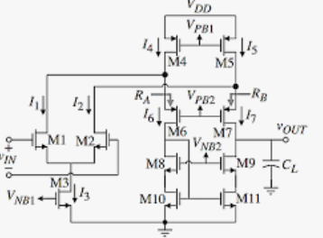
Fig.1. Circuit of NMOS- pair folded cascode
In the present work, the NMOS input pair folded cascode operational amplifier operates by converting the differential input voltage into a high-gain output voltage through multiple gain-enhancing stages. The input signal is applied to the NMOS differential pair (M1 and M2), which converts the input voltage difference into corresponding drain currents (I1 and I2). These currents are controlled by the tail current source transistor M3, which is biased using (V_{NB1}) to ensure stable operation in the saturation region. The differential currents from M1 and M2 are then “folded” through the PMOS transistors M4 and M5, which act as active loads and current mirrors, redirecting the current from the NMOS input stage to the next stage while improving voltage headroom.The folded currents flow through transistors M6 and M7, which form part of the cascode structure and enhance the output resistance, thereby increasing the overall gain of the amplifier. The bias voltage (V_{PB2}) ensures that M6 and M7 remain in saturation. Further, transistors M8 and M9, along with M10 and M11, form current mirrors and provide additional gain while properly biasing the lower branch of the circuit using (V_{NB2}). The output is taken from the drain of M9, where the amplified signal is developed across the load capacitor (C_L). The resistors (R_A) and (R_B) help in stabilizing the operating point and controlling the current flow in the folded branches.
Overall, the folded cascode topology allows efficient level shifting of currents from the input stage to the output stage, enabling high gain, wide bandwidth, and improved output swing even under low supply voltage conditions.

Design Specifications
The calculations for the 5V NMOS pair Folded Cascode amplifier is shown as follows:
TABLE II. Design Parameters
Parameters | Values
VDD | 5 V
VSS | GND
Vtn | 0.7 V
Vtp | 1.07 V
Vov | 0.2 V
Kn | 220uA/V²
Kp | 70uA/V²

Input Common Mode Range (ICMR):
The calculations below are for Input Common Mode Ratio for the given circuit :
- Maximum Input Voltage:
Vmax = Vdd – ( Vov1 + Vtn)
Vmax = 5 – (0.2+0.7)
Vmax = 4.1V
- Maximum Output Voltage:
Vmin = Vss + 2Vov1 + Vtn
Vmin = 0.4 + 0.7
Vmin = 1.1V
BIAS VOLTAGE CALULATIONS:
The calculations below are for Bias Voltages for the given circuit :
Vb1 = Vdd – Vov – Vtp
= 5 – 0.2 – 1.07 = 3.73 V
Vb2 = Vdd – 2Vov – Vtp
= 5 – 0.4 – 1.07 = 3.53 V
Vb3 = 2Vov + Vtn
= 0.4 + 0.7 = 1.1 V
OUTPUT RANGE:
The calculations below are for Output Ranges for the given circuit :
Vout(max) = Vdd – Vov
= 5 – 0.2 = 4.8V
Vout(min) = Vss + Vov
= 0 + 0.2 = 0.2V

TABLE III. (W/L) Ratio
TRANSISTOR NAME | (W/L) RATIO in (µ/ µ )
M1 , M2 | 20/0.5
M3 | 55/1
M4, M5 | 85/1.4
M6, M7 | 85 /1.4
M8, M9 | 16/1
M10 , M11 | 16/1

Simulation Results

Open Loop
The schematic of a open loop NMOS pair Folded cascode amplifier using 0.35um technology is shown in Fig. 2. The output waveform of the given amplifier as shown in Fig .3.

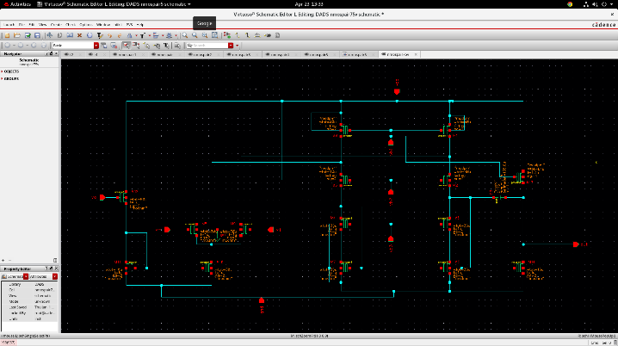
Fig . 2. Open Loop Folded cascode amplifier

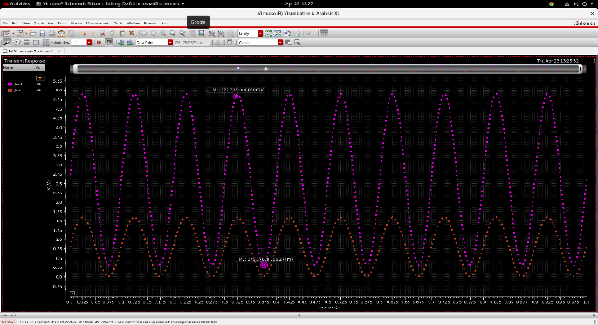
Fig .3. Output Waveform of the Amplifier

Closed Loop
The schematic of a closed loop NMOS pair Folded cascode amplifier using 0.35um technology is shown in Fig. 4. The output waveform of the given amplifier as shown in Fig .5
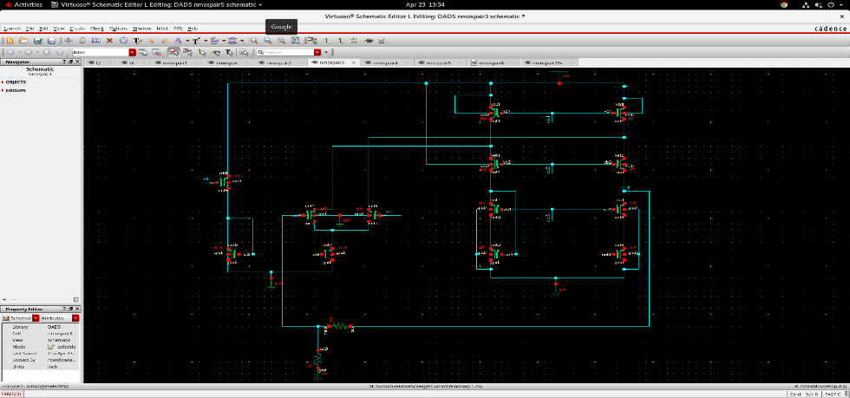

Fig.4. Closed Loop Folded Cascode Amplifier.

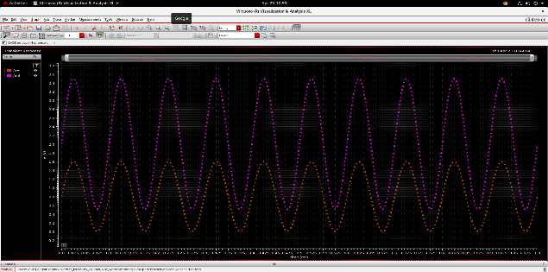
Fig. 5. Output Waveform of the given amplifier.

TABLE III. RESULTS
Parameter | Value
Input Voltage | 1.6 V
Output Ranges for open Loop | [0.3 V, 4.83 V]
Output Ranges for Closed loop | [0.7 V, 3.5 V]
Area | 12.75mm²

Conclusion

The NMOS input pair folded cascode amplifier presented in this work successfully achieves high gain, wide bandwidth, and improved output voltage swing within a 5 V supply. By employing a folded cascode topology, the design effectively overcomes the voltage headroom limitations of conventional cascode amplifiers, enabling a large output swing close to the supply rails. The use of an NMOS differential input pair enhances transconductance, resulting in better speed and frequency response.The calculated input common-mode range of 1.1 V to 4.1 V and output swing of 0.2 V to 4.8 V demonstrate efficient utilization of the available supply voltage. Additionally, the design meets key performance requirements such as high gain-bandwidth product and fast slew rate, making it suitable for high-speed and precision analog applications.Overall, the NMOS folded cascode amplifier provides a good trade-off between gain, speed, power consumption, and output swing, making it a reliable choice for modern analog and mixed-signal integrated circuit designs.

Referrences
[1] P. R. Gray, P. J. Hurst, S. H. Lewis, and R. G. Meyer, Analysis and Design of Analog Integrated Circuits, 5th ed. New York, NY, USA: Wiley, 2009.
[2] B. Razavi, Design of Analog CMOS Integrated Circuits. New York, NY, USA: McGraw-Hill, 2001.
[3] T. H. Lee, The Design of CMOS Radio-Frequency Integrated Circuits, 2nd ed. Cambridge, U.K.: Cambridge Univ. Press, 2004.
[4] A. S. Sedra and K. C. Smith, Microelectronic Circuits, 7th ed. New York, NY, USA: Oxford Univ. Press, 2014.
[5] R. J. Baker, CMOS: Circuit Design, Layout, and Simulation, 3rd ed. Hoboken, NJ, USA: Wiley-IEEE Press, 2010.
[6] J. M. Rabaey, A. Chandrakasan, and B. Nikolić, Digital Integrated Circuits: A Design Perspective, 2nd ed. Upper Saddle River, NJ, USA: Prentice Hall, 2003.
[7] K. Bult and G. J. G. M. Geelen, “A fast-settling CMOS op amp for SC circuits with 90-dB DC gain,” IEEE Journal of Solid-State Circuits, vol. 25, no. 6, pp. 1379–1384, Dec. 1990.
[8] J. H. Huijsing, “Operational amplifiers: Theory and design,” Kluwer Academic Publishers, 2001.
[9] G. Palmisano and G. Palumbo, “A novel CMOS folded cascode operational amplifier,” IEEE Transactions on Circuits and Systems II, vol. 42, no. 7, pp. 455–457, Jul. 1995.
[10] S. Franco, Design with Operational Amplifiers and Analog Integrated Circuits, 3rd ed. New York, NY, USA: McGraw-Hill, 2002.

